**Question – 1 Write a function to calculate the area of a circle. (TSRS)**

**Ans.**

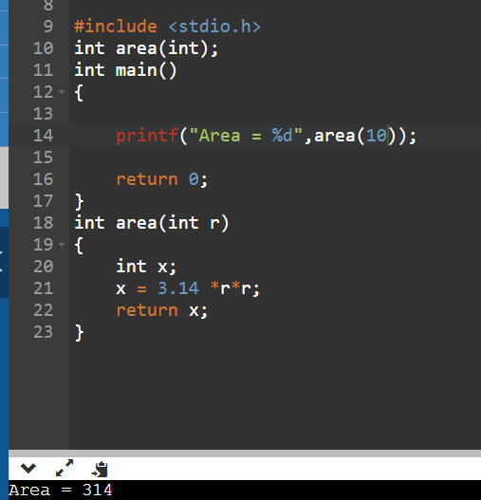

**Question -2 Write a function to calculate simple interest. (TSRS)**

**Ans.**

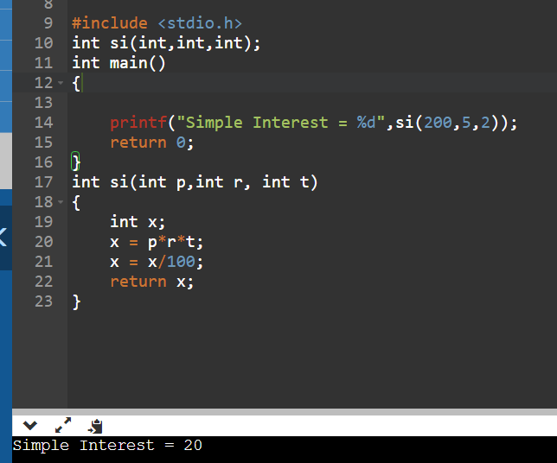

**Question – 3 Write a function to check whether a given number is even or odd. Return 1 if the number is even, otherwise return 0. (TSRS)**

**Ans.**

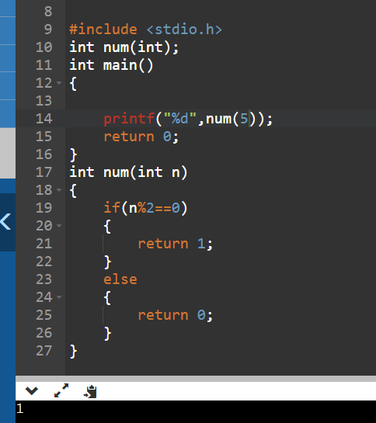

**Question – 4 Write a function to print first N natural numbers (TSRN)**

**Ans.**

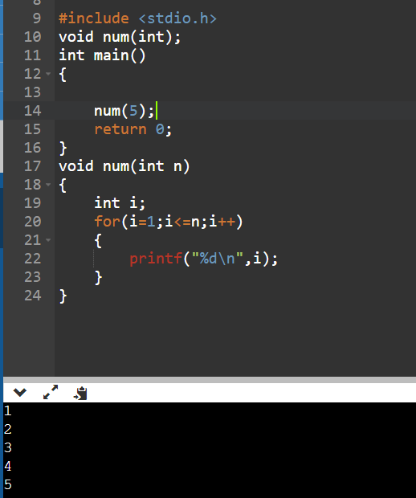

**Question – 5 Write a function to print first N odd natural numbers. (TSRN)**

**Ans.**

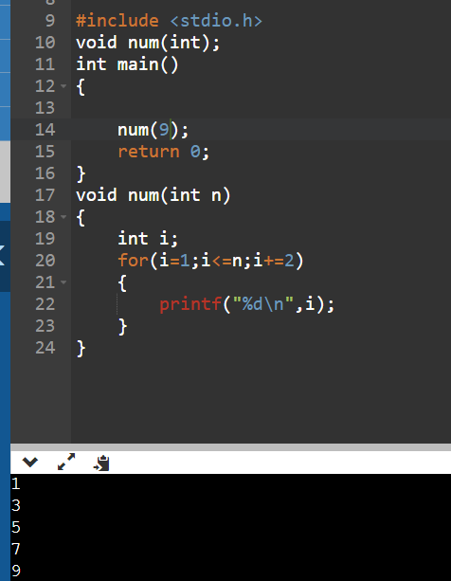

**Question – 6 Write a function to calculate the factorial of a number. (TSRS)**

**Ans.**

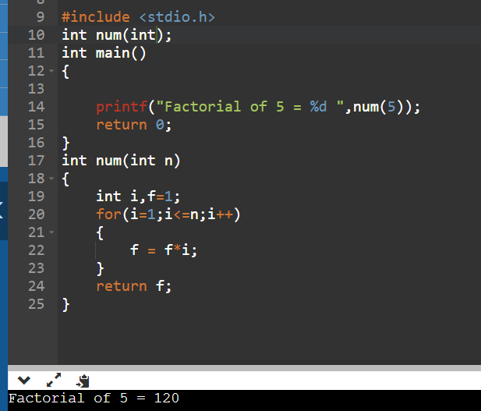

**Question – 7 Write a function to calculate the number of combinations one can make from n items and r selected at a time. (TSRS)**

**Ans.**

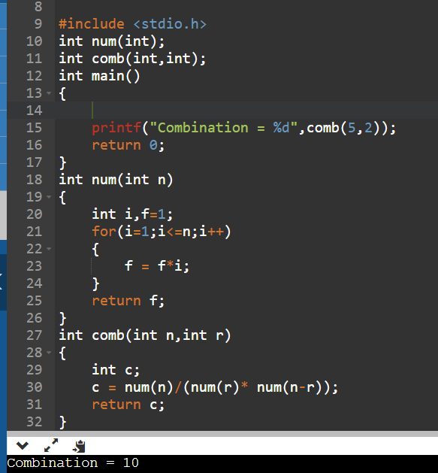

**Question – 8 Write a function to calculate the number of arrangements one can make from n items and r selected at a time. (TSRS)**

**Ans.**

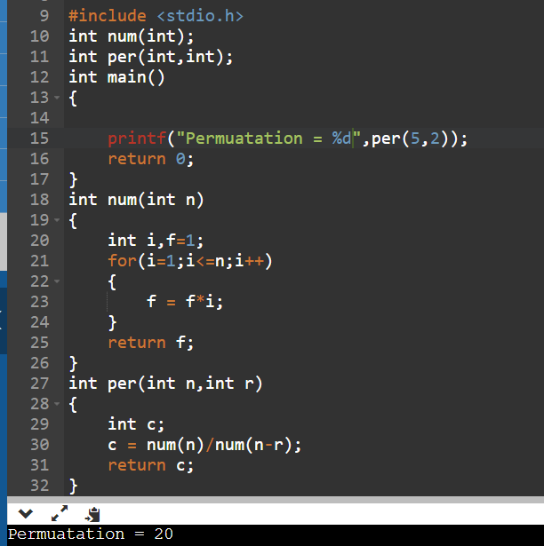

**Question – 9 Write a function to check whether a given number contains a given digit or not. (TSRS)**

**Ans.**

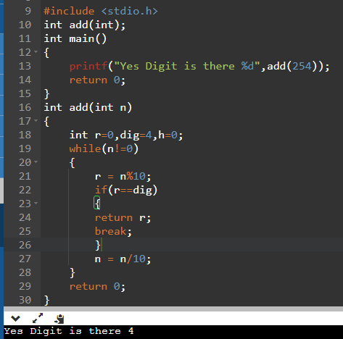

**Question – 10 Write a function to print all prime factors of a given number. For example, if the number is 36 then your result should be 2, 2, 3, 3. (TSRN)**

**Ans.**

